Deploy a Static Website on AWS

INTRODUCTION
A static website is a type of website where the content remains the same for all users and doesn't change dynamically based on user interaction or other factors. It's essentially a collection of pre-built HTML, CSS, and JavaScript files served directly to the user's browser without any server-side processing. This results in fast loading times and simple hosting, but with limited interactivity and content personalization.
Key Characteristics:
Fixed content- The content on a static website is predetermined and doesn't change unless manually updated by the website's administrator.
Clint-side rendering- Static websites rely on the user's browser (client-side) to render the content, meaning the web server simply sends the pre-built files.
No Database or Server-Side Logic- Unlike dynamic websites, static websites don't use databases or server-side scripting languages like PHP, Python, or Ruby to generate content.

Simple Structure- Static websites typically consist of HTML, CSS, and JavaScript files.

Common Uses- They are often used for brochure websites, portfolios, landing pages, and informational sites where content doesn't need to be updated frequently.
Advantages of static website-
- Static websites load quickly because they don't require server-side processing or database queries.
- They are generally cheaper to host and maintain.
- Static websites are inherently more secure because they don't have a database or server-side scripting that could be vulnerable to attacks.
- Static websites can easily handle a large number of users without performance degradation.

Disadvantages of static website-
  - Static websites offer limited interactivity compared to dynamic websites.
  - Updating the content of a static website requires manual changes to the files.
  - Static websites can't easily personalize content for individual users.

Table Of Content
- Introduction
- Setup Check list for Mini Project
- Problem Statement
- Technology used
- Setup Check list for Mini Project

- HARDWARE
- 12th Gen Intel(R) Core(TM) i7-1255U 1.70 GHz
- Windows 11 Pro
- Memory: 16GB RAM / 512GB Storage
- SOFTWARE
- Work on AWS management Console
In static website
TECHNOLOGY USED
AWS CONSOLE MANAGEMENT

Lab steps

Step 1: Sign in to AWS Management Console
- Click on the Open Console button, and you will get redirected to AWS Console in a new browser tab.

- On the AWS sign-in page.
  - Leave the Account ID as default. Never edit/remove the 12-digit Account ID present in the AWS Console. otherwise, you cannot proceed with the lab.
  - Now copy your User Name and Password in the Lab Console to the IAM Username and Password in AWS Console and click on the Sign in button or login to root user.

- Note- Only the person who has the personal AWS account can log in as the root user.


- Once Signed In to the AWS Management Console, Make the default AWS Region as US East (N. Virginia) us-east-1.
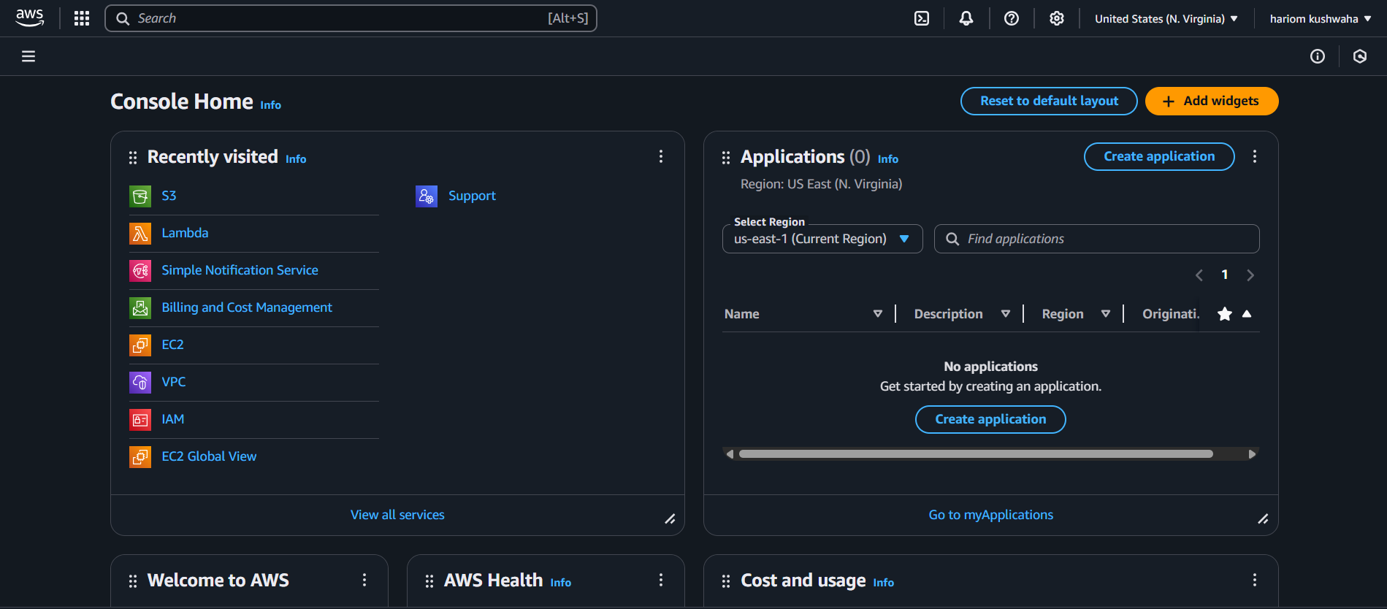

Step 2: Creating a S3 Bucket
In this step, we are going to create a new S3 bucket in the US East (N. Virginia) region with a unique name disabling ACLs, and allowing public access for hosting the static website.

- Navigate to S3 by clicking on the Services menu at the top, then click on S3 in the Storage section
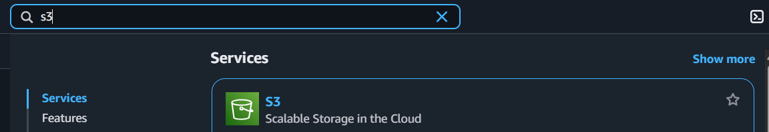
- In the S3 dashboard, click on the Create Bucket button.
- In the General Configuration, Bucket name.
- AWS Region: Select US East (N. Virginia) us-east-1
- Object ownership: Select ACLs disabled (recommended) option
- In the option of Block Public Access settings for this bucket, Uncheck the option of Block all public access.
  - Check the I acknowledge that the current settings might result in this bucket and the objects within becoming public checkbox
.
- . Keep everything default and click on Create Bucket button.

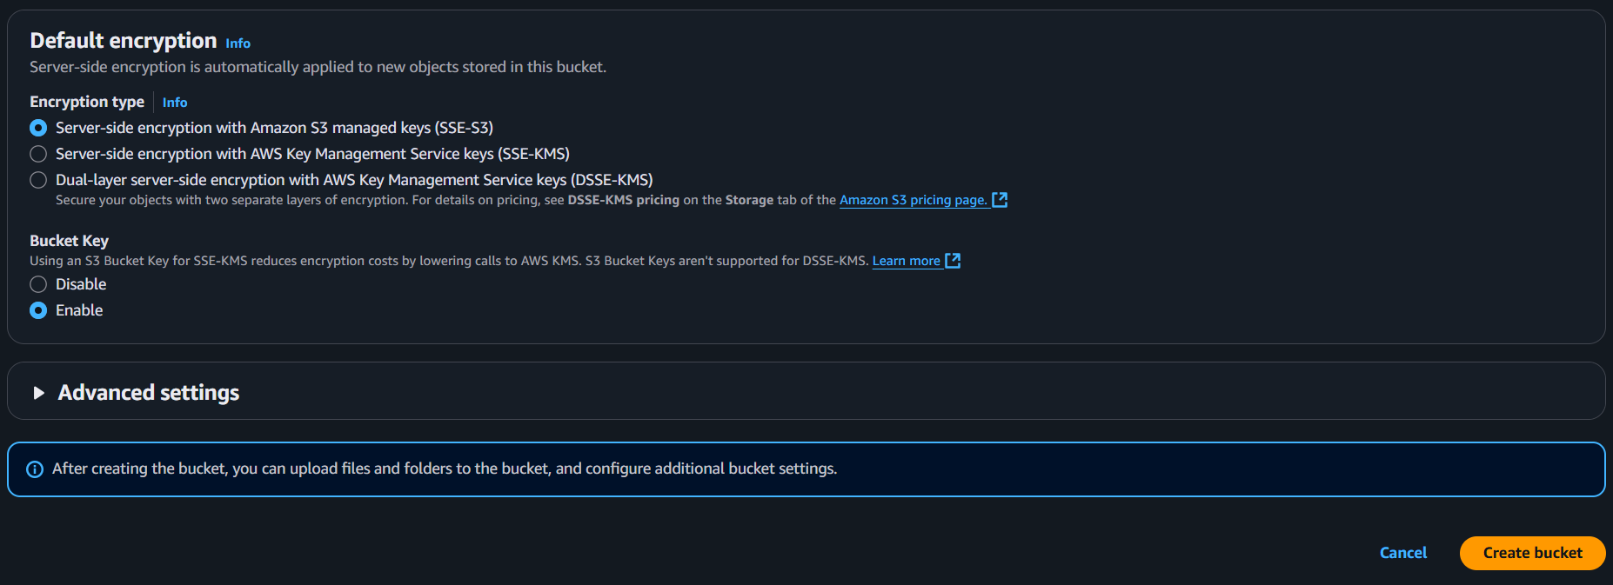
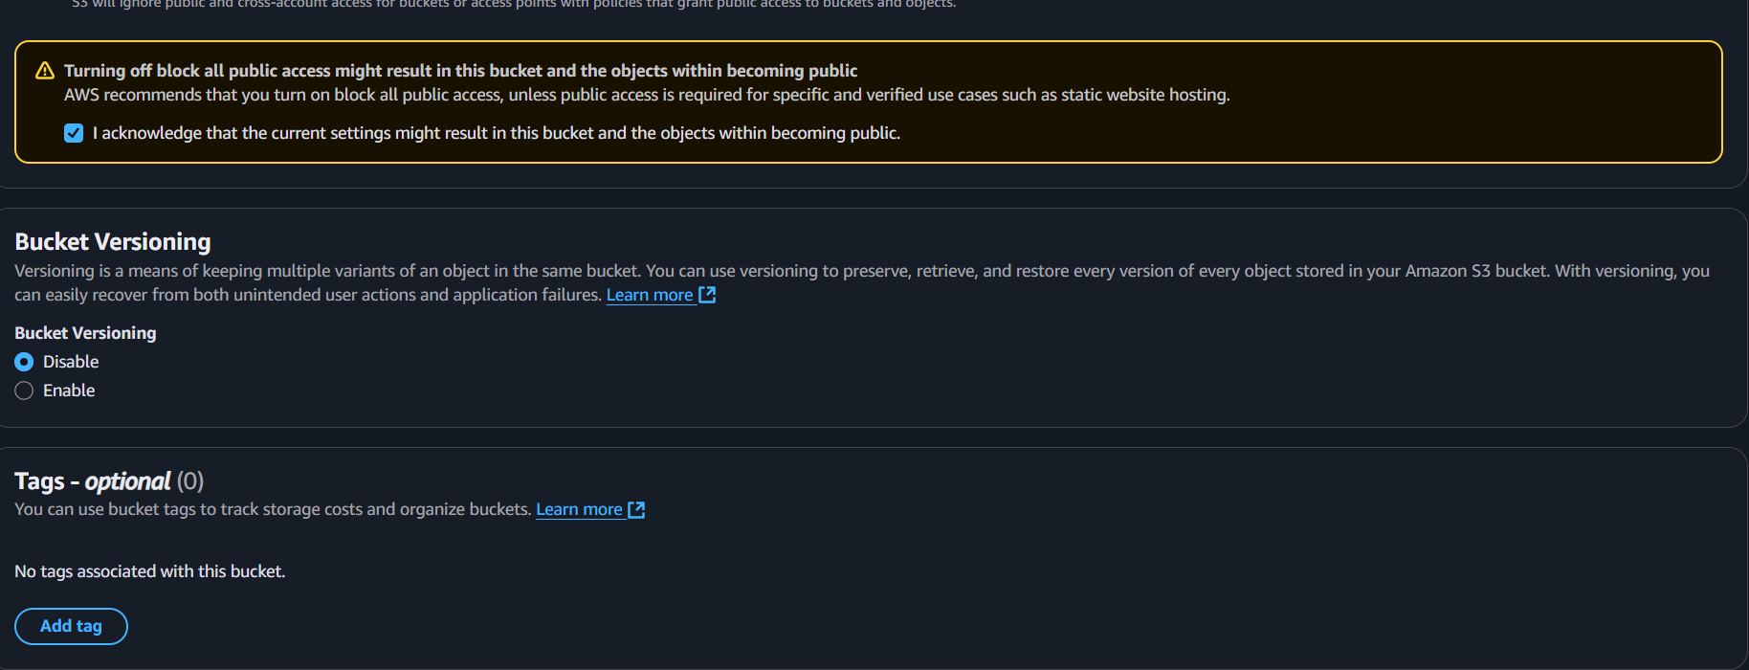
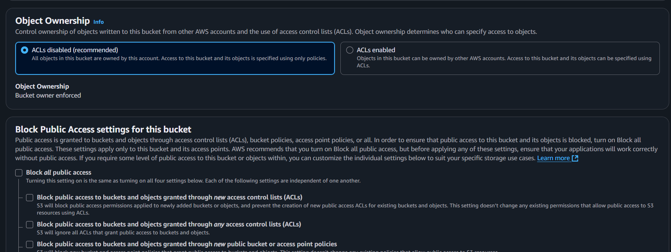
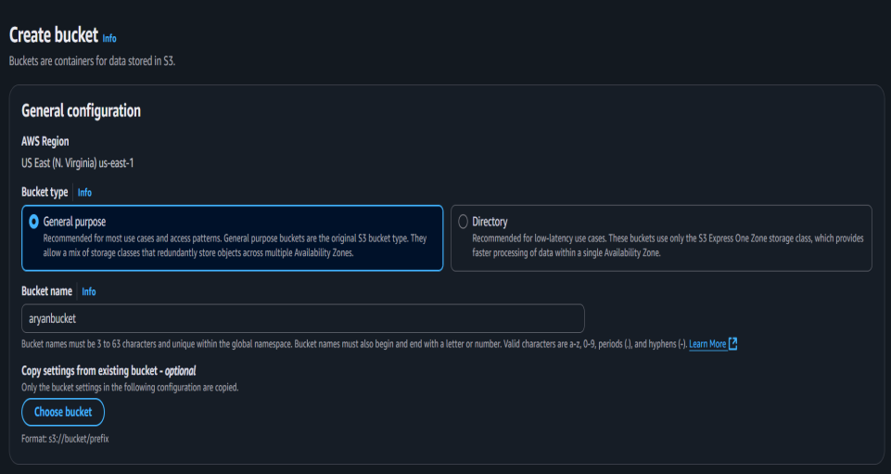
Step 3: Enable Static Website Hosting settings
In this task, we will enable static website hosting for our S3 bucket, configure it to use index.html and error.html, copy the provided endpoint, upload two files, and configure the bucket policy by copying its ARN and pasting the provided policy code.

- To proceed, go to the S3 bucket name that you created and click on it. After that, navigate to the Properties tab which can be found at the top of the screen.

- Scroll down to the Static website hosting section and click on Edit button.

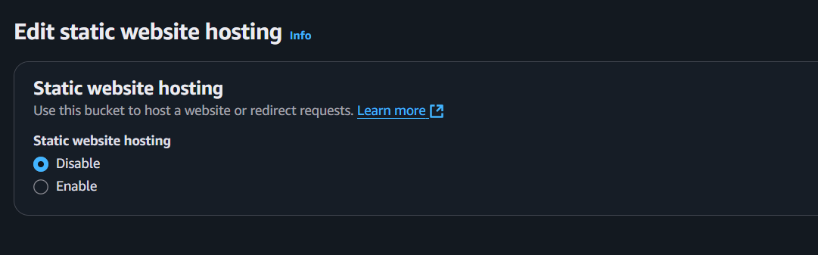
- In the Static website hosting dialog box
- Static website hosting: Select Enable
- Hosting type: Choose Host a static website
- Index document: Type index.html
- Error document: Type error.html
- Click on Save Changes.
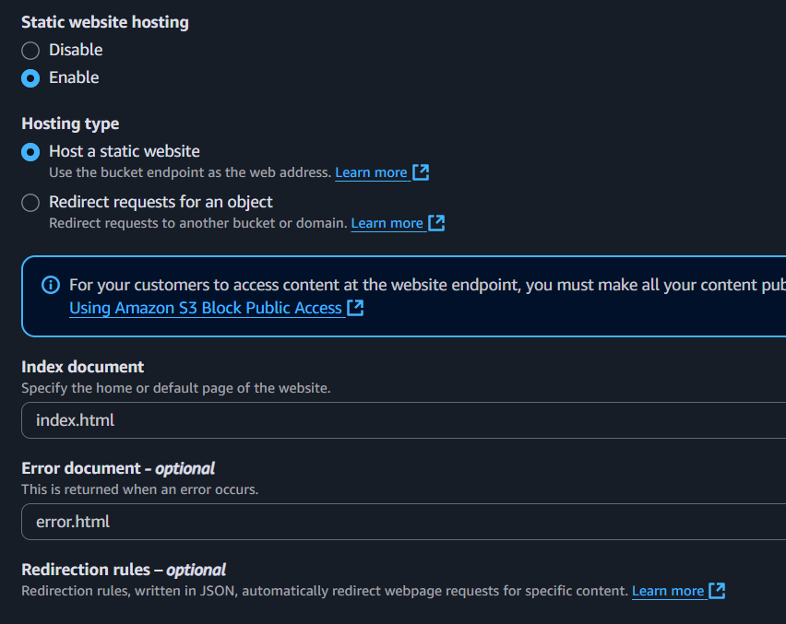
4. Go to the Properties tab of your S3 bucket, and find the Static website hosting section. Copy the Endpoint provided in this section to your clipboard and save it for future reference.
- The next step is to download the zip file by clicking on the link, extract it, and upload two files named index.html and error.html to the S3 bucket you created earlier.

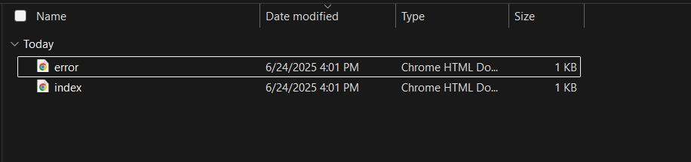
6. To configure your S3 bucket, access the Permissions tab and make the necessary configurations.
- In the Permissions tab, Click on the Edit button beside the Bucket Policy.
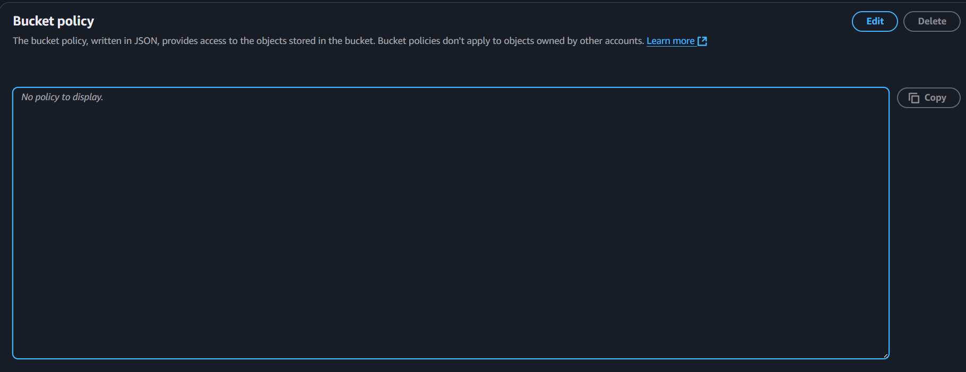
- You will be able to see a Blank policy editor.
- Before creating the policy, you will need to copy the ARN (Amazon Resource Name) of your bucket.
- Copy the ARN of your bucket to the clipboard. It is displayed at the top of the policy editor. it will look like ARN:“arn:aws:s3:::your-bucket-name".
- In the policy below, Update the bucket ARN on the Resource key value and paste the below policy code in the editor.

{

"Id":"Policy1",
"Version":"2012-10-17",
"Statement":[
{
"Sid":"Stmt1",
"Action":[
"s3:GetObject"
],
"Effect":"Allow",
"Resource":"replace-this-string-with-your-bucket-arn/*",
"Principal":"*"
}
]
}
- Click on Save changes button.

Step 4: Test the website
- Now copy the static website URL (that we saved earlier) and run it in your browser. You will be able to see the index.html file's text. A sample screenshot is attached below:

Step 5: Test the website's error page
- Copy the static website URL (which we saved earlier) , but this time, add some random characters to the end of the url to break it. When satisfied, hit [Enter]. You will be redirected to the error.html page automatically.

